**BRAC UNIVERSITY**

**DEPT. OF COMPUTER SCIENCE AND ENGINEERING COURSE NO.: CSE250**

**Circuits and Electronics Laboratory**

**Experiment No. 6**

**Name: Shihab Muhtasim**

**ID:21301610**

**Sec:19**

**SUMMER 22**

**Name Of The Experiment:**

# Verification of Thevenin’s Theorem and Maximum Power Transfer Theorem (SIMULATION).

**PART 1:**

# OBJECTIVE:

To verify Thevenin's theorem with reference to a given circuit theoretically as well as experimentally.

# CIRCUIT DIAGRAM:

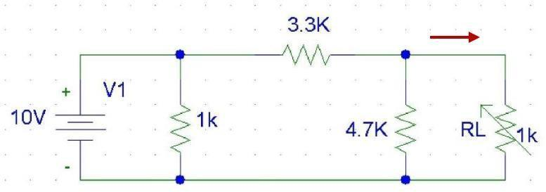  
  
  
  
  
  
  
  
  
**REPORT:**

1. Find theoretically the Thevenin equivalent circuit for the values of R0, R2, R3 & VS recorded in table. Also find IL, VL.

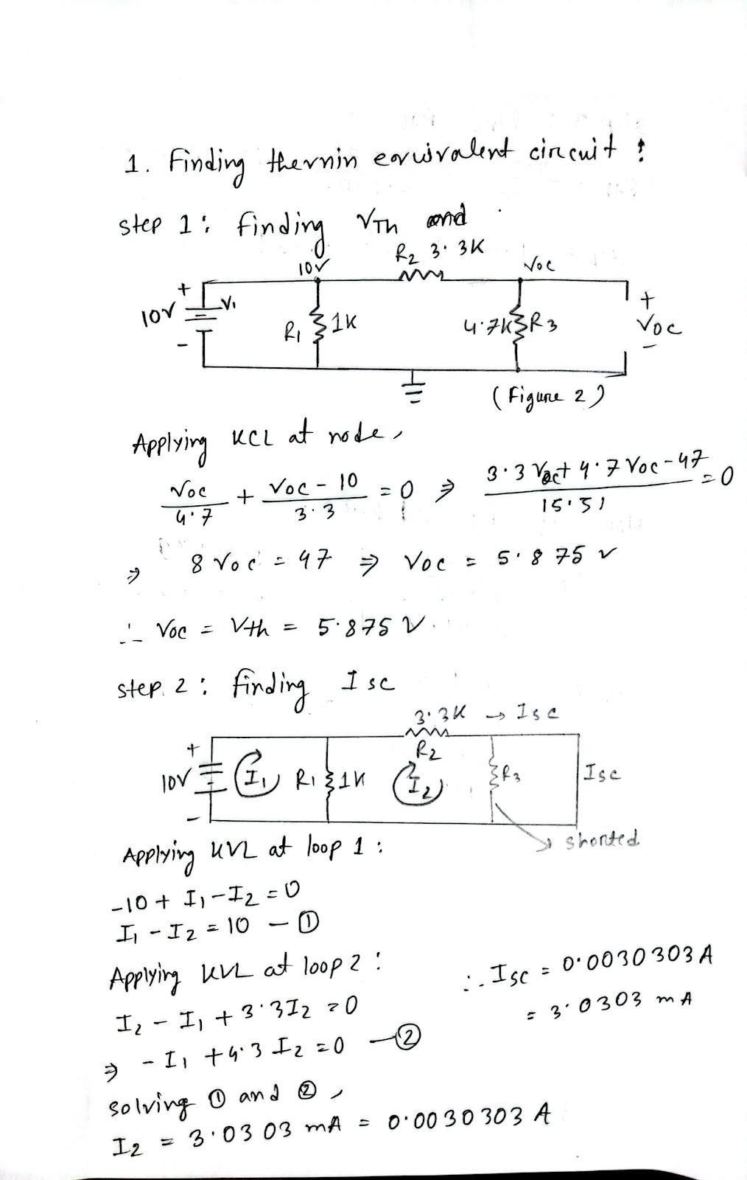

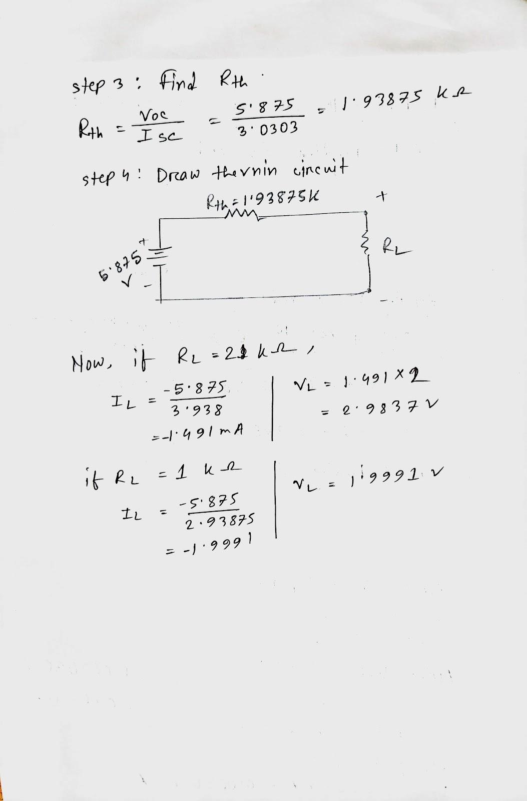

1. Show the results in tabular form.

# DATA:

| R1 (kΩ) | R2 (kΩ) | R3 (kΩ) |
| --- | --- | --- |
| 1 | 3.3 | 4.7 |

| Circuit | No. of Obs. | RL (kΩ) | Load Voltage | Load current |
| --- | --- | --- | --- | --- |
| VL (V) | IL = VL/RL (mA) |
| For | 1. | 1 | 1.99915 | 1.99915 |
| circuit 1 | 2. | 2 | 2.98318 | 1.49159 |

| RTH=VTH/ISC(kΩ) |
| --- |
| 1.93875 |

|  | VOC (V) |  | | For circuit 3 | | ISC = V2/R2 |  |  |
| --- | --- | --- | --- | --- | --- | --- | --- | --- |
| For | (mA) |  |
| circuit 2 | 5.875 | 3.0303 |  |
|  | | | | | | |  |
| Circuit | No. of Obs. | RL (kΩ) | Load Voltage | |  | Load current |  |  |
|  | VL (V) | IL = VL/RL (mA) | |  |  |
| For | 1. | 1 | 1.9991 | | 1.9991 | |  |
| circuit 4 | 2. | 2 | 2.9837 | | 1.491 | |  |

1. **Attach all the screenshots of circuits and results/plots in your report.**

FIGURE 1

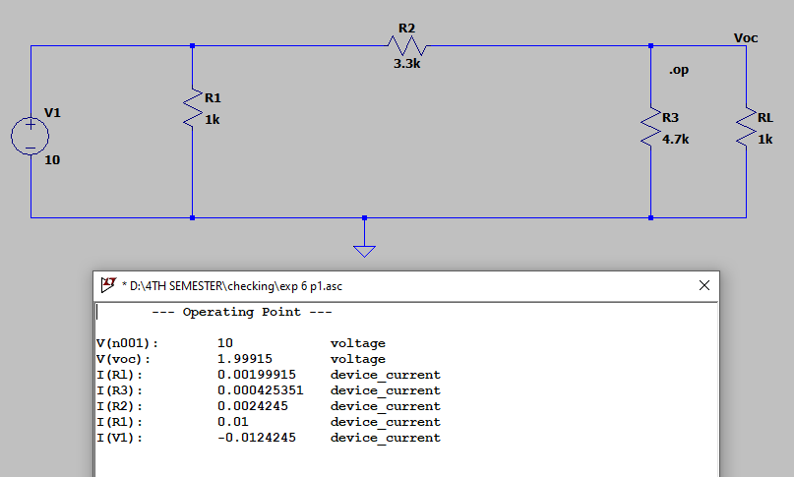

FIGURE 2

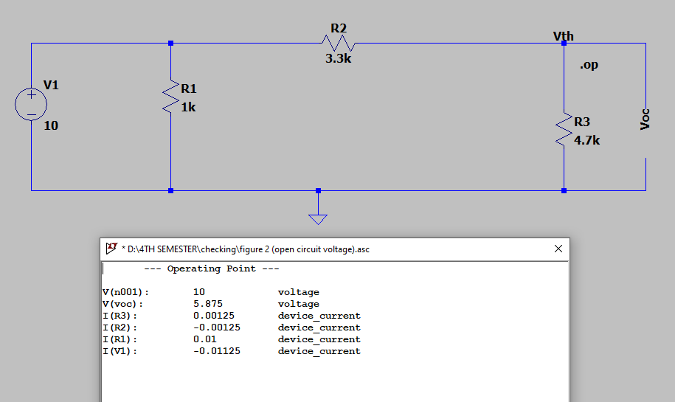

FIGURE 3

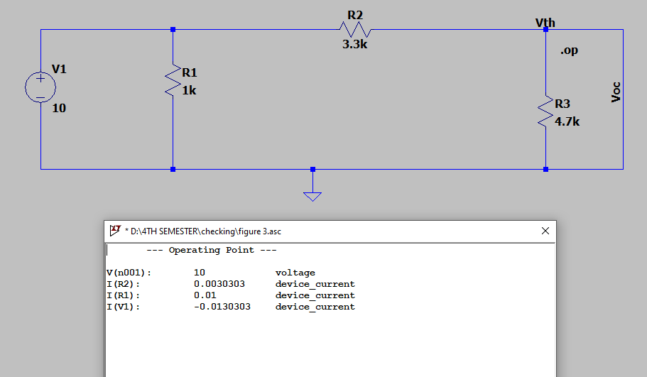

FIGURE 4

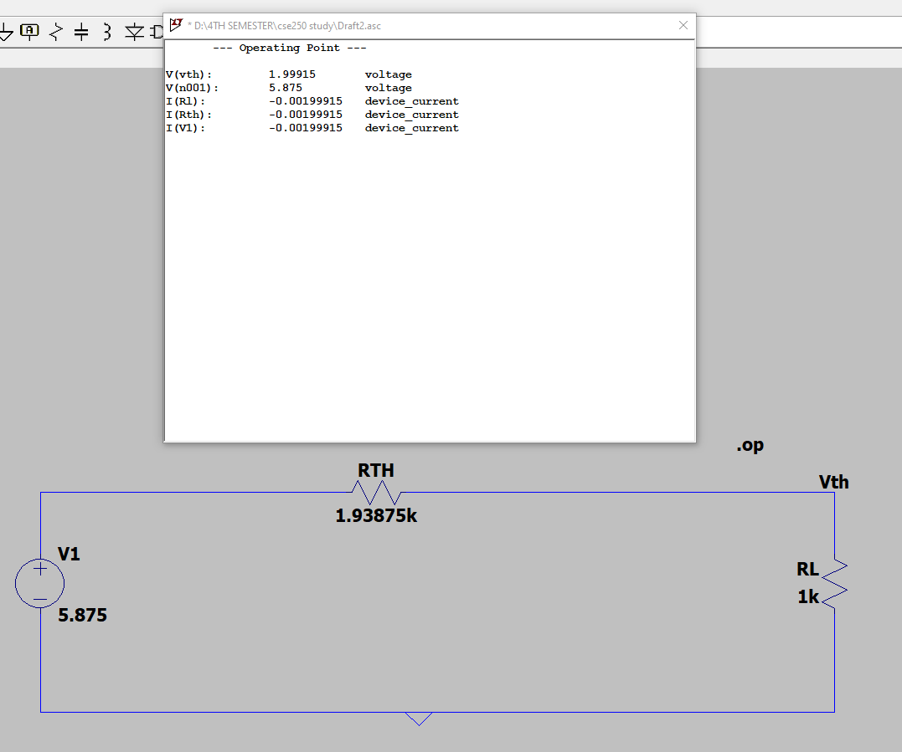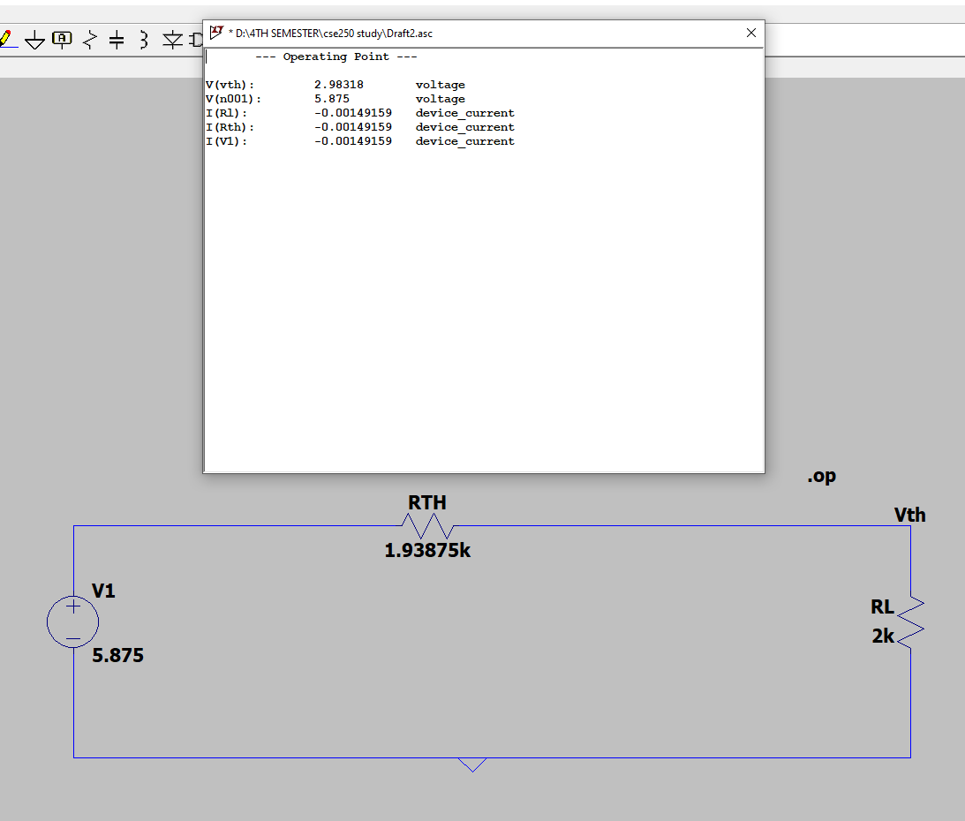

# QUESTION:

1. **Define unilateral, bilateral & equivalent circuit.**

Unilateral circuits are electrical or electronic circuits that have at least one unilateral component. When the direction of current is altered in such circuits, the characteristics or properties of the circuit may change.

A bilateral circuit is one in which the characteristics of its components are independent of the direction of current flow. No discernible change in the behavior of the circuit would be seen if the current direction in the circuit were reversed. Consider a resistor circuit.

A theoretical circuit that preserves all of the electrical properties of a specific circuit is referred to as an equivalent circuit. It is constructed using the fundamental components resistance, inductance, and capacitance in a straightforward configuration to mimic the functionality of a more complex circuit or network.

1. **Describe other methods for determining Thevenin resistance.**

Another method involves first removing the load resistance and then applying a DC driving voltage (Vdc) to the open-circuited load terminals in order to determine the internal impedance. In the event that a direct current is applied to the load terminal, keep the other independent sources off. This indicates that the current source is open-circuited while the terminals of the voltage source are short-circuited. A DC driving current (idc) begins to flow in the circuit of the load terminals when the voltage from the DC supply is applied to the load terminal. This is as a result of the vdc application. The equation below can be used to determine the source network's internal impedance: Rth=Vdc/Idc

1. **Mention the advantages of using Thevenin Theorem.**

A simple method for assessing power circuits, which frequently have a load that changes value throughout the analysis process, is provided by Thevenin's Theorem. Without having to redo your entire circuit, this theorem offers an effective technique to determine the voltage and current flowing across a load. Thevenin's Theorem is particularly helpful when analyzing power systems and other circuits that contain a single resistor that is subject to change (referred to as the "load" resistor), necessitating a recalculation of the circuit for each possible value of the load resistance in order to determine the voltage across it and the current through it.

**PART 2:**

**OBJECTIVE:** The objective of this experiment is to verify the maximum power transfer theorem.

**CIRCUIT DIAGRAM:**

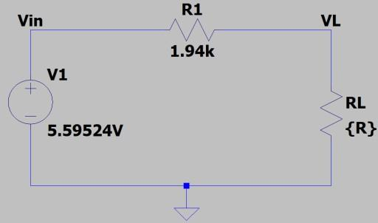

Fig. 5: Circuit schematic for maximum power transfer theorem ver

# REPORT:

Plot the following:

* + % η vs RL.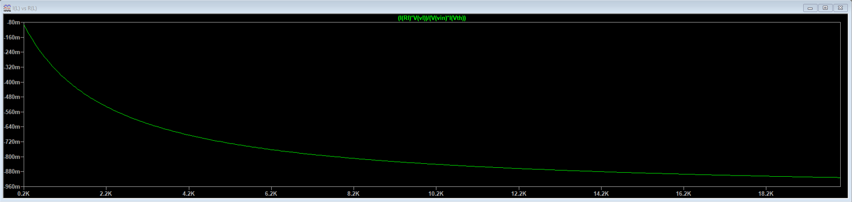
  + Loss (Pin – Pout) vs RL.

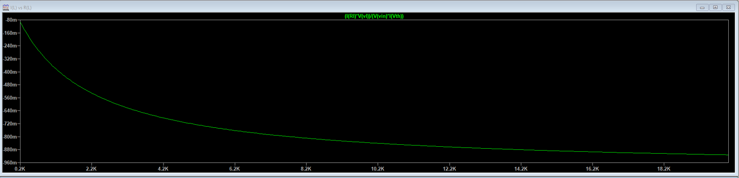

* + VL vs RL.

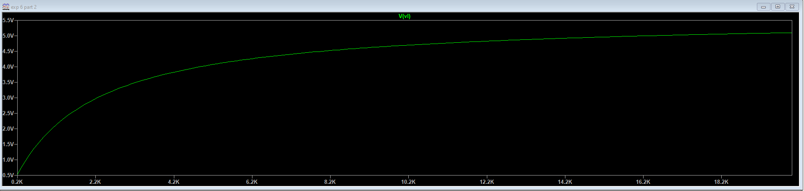

* + IL vs RL.

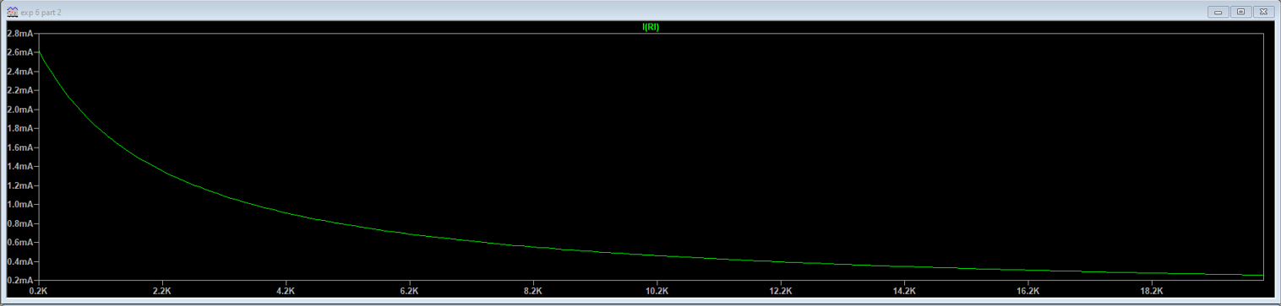

* + PL vs RL

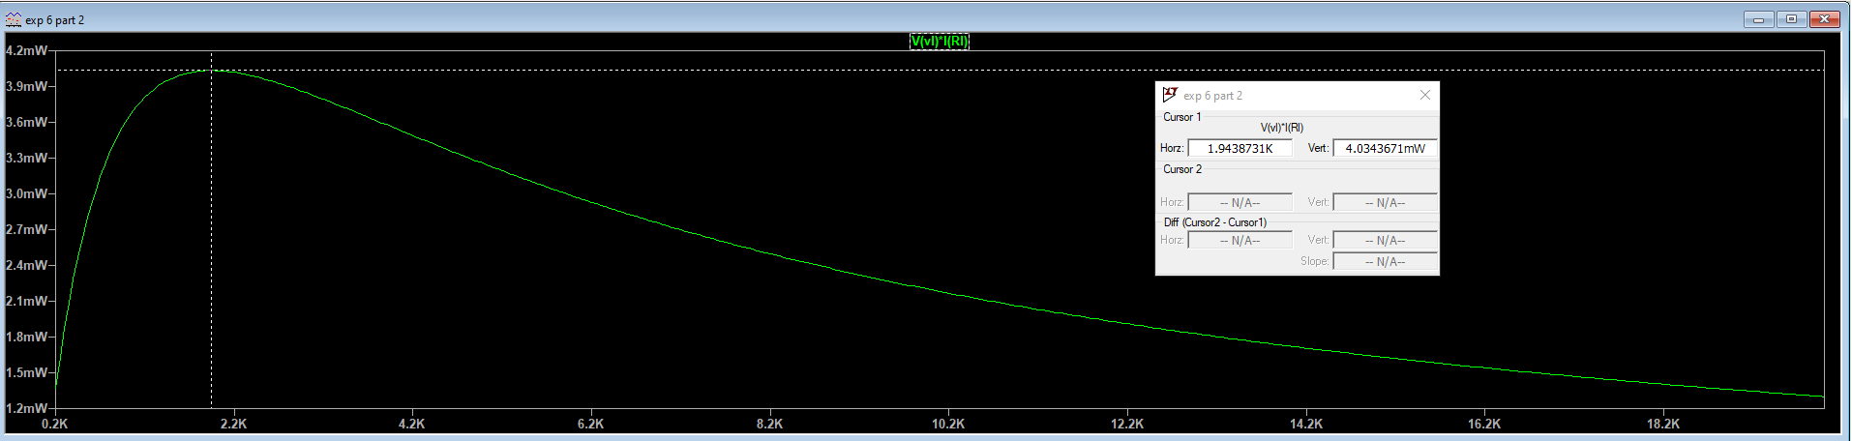

# QUESTIONS:

1. **Why high voltage transmission is used in case of transmitting electric power?**

Because a greater voltage indicates a lower current for a given power of transmission, high voltages are used in transmission systems. Less heat is produced in the transmission lines with a lower current, which results in less energy being squandered.

1. **Where is maximum power transfer used?**

The maximum power transfer is used in DC circuits which defines the statement of highest power transfer from an active network toward an exterior load resistance.

MPTT is applied in Radio communications, where the power amplifier transmits the maximum amount of signal to the antenna if and only if load impedance in the circuit is equal to the source impedance.

It is also applied in audio systems, where the voice is to be transmitted to the speaker. The amplifier amplifies the maximum amount of voice when the load impedance is equal to the source impedance.

1. **Why instead of transmitting maximum power, power utility transmits power at maximum efficiency?**

If the internal resistance of the source and the load are equivalent, the maximum amount of power can be transferred from the source to the load. Half of the electricity will be used in Rs and half in Rl if Rs = Rl. So, 50% efficiency will result. Power producers never use this theory because of its poor efficiency.In a perfect world, utilities would transport power as efficiently as possible since doing so would reduce generation costs by minimizing losses on the lines and in the transformers. However, rising capital expenses accompany each gain in efficiency. There is always a trade off between investing in distribution transformers, which are less expensive but have higher losses, and efficient power transformers. That is why instead of transmitting maximum power, power utility transmits power at maximum efficiency.

1. **Deduce the condition for maximum power transfer.**

The condition for maximum power dissipation across the load **RL=RTh**.  That means, if the value of load resistance is equal to the value of source resistance i.e., Thevenin's resistance, then the power dissipated across the load will be of maximum value.

